**Experiment No: 02**

**Aim: Develop Software Requirements Specifications (SRS) in IEEE Format for a given Project**

**1. Introduction**

SMS and Email Spam detection is a project that will help us reduce some cybercrimes that start from spam messages received on your phone or Mailbox.

**1.1**  **Purpose**

This document presents a detailed explanation of objectives, features, user interface and application of SMS and Email Spam detection in real life. It will also describe how this system will perform and under which it must operate. The main purpose is to spread awareness about Cyber security and crimes and how to avoid frauds and not getting involved in such scams.

**1.2**  **Scope**

The Software Requirements Specification captures all the requirements in a single document. The project that is to be developed provides the user information about how not to get hacked, how to stay away from cyber crimes.

The project provides an approach to cyber security systems that functions quickly and predicts accurately whether the pasted text is spam or not with much efficient machine learning algorithm.

**1.3**  **Definitions, Abbreviations and Acronyms**

SMS: Short Messaging Service

Email: Electronic Mail

NLP: Natural Language Processing

DB:Database

SQL:Structured Query Language

Python: A programming Language

Flask: Micro web framework written in Python

TensorFlow: Python library used for fast numerical computation developed by Google

**1.4 References**

Leadingindia.ai

<https://www.leadingindia.ai/downloads/projects/CS/cs_5.pdf>

**1.5 Overview**

Short Message Service has been one of the finest communication modes considering the development in  mobile communication systems. With the advancement in this technology, it's simple operation and low cost, has led to the usage of SMS. But this has brought in the problem of spams. So, it's necessary to identify these mobile attacks and keep personal data on phone secure. Same case will be for Emails. Detection of spam will help in blocking messages and filtering them. This Cyber Security System will involve Neural Networks and NLP. Collected dataset of spam messages will be pre-processed and classification methods will be applied.

**2. Overall Description**

**2.1 Product Perspective**

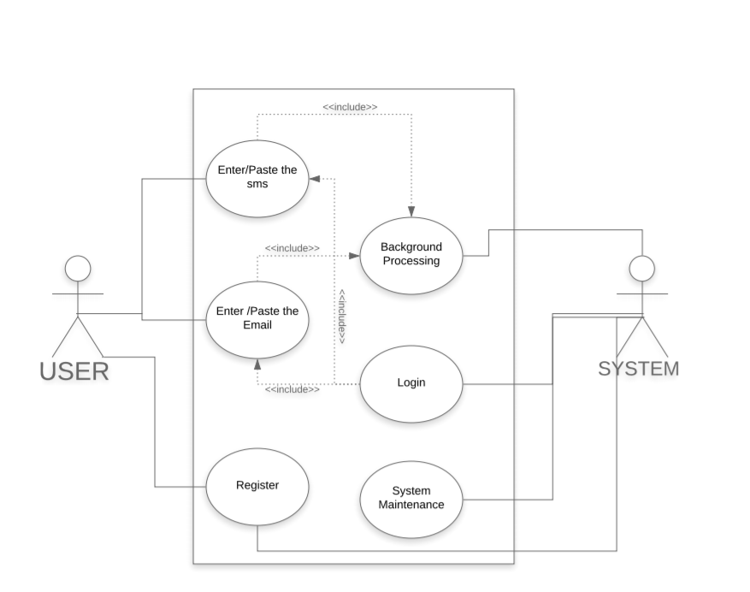

**Figure 1:Use case Diagram for Spam SMS and Email Detection**

This is a broad level diagram of the project showing a basic overview. The User will either have to login first and then will be redirected to homepage or will have to register first to save credentials and then login to get redirected to homepage. The user will enter or paste the Email or SMS to classify it as Spam or not. Once the message is entered in the User interface the system will apply machine learning to do the processing and output Spam or not to the User.

**2.2 Product Functions**

This system provides real time classification of the messages if they are harmful or not.The main purpose of this system is to prevent users from being frauded through messages.The software will be capable of storing users data when registering and let them log in.It is capable to apply machine learning to process messages and predict if it will be Spam or not.The system will record all the messages with predictions and maintain better accuracy.

**2.3 User Characteristics**

The project has different types of services to only registered users.The System will be controlling the software where as the user will only access the site.

The features of the software are:

* The User can use the software by pasting the SMS to check if the SMS is spam or ham
* The User can use the software by pasting the Email to check if the Email is spam or ham

**2.4 General Characteristics**

Some of the General Characteristics can be given as:

* The Software is operable and easily understable by the user.
* The details of the users are stored in a well-secured database.
* The displayed output is stored for further processing and prediction.
* The displayed output is accurate and helps the user in being decisive on sharing personal information over Emails and SMSs.
* The admin has access to all the information and updates the system when in need.

**2.5 Assumptions and Dependencies**

The assumptions are:

* The coding should be error free.
* The system should be user-friendly so that it is easy to use for the users.
* The information and credentials of all users will be stored in the database.
* The system should be able to apply proper machine learning processing to classify messages as Spam or not.
* The system should have more storage capacity and provide fast access to the database.
* Users may access from any computer that has Internet browsing capabilities and an Internet Connection.
* Users must have correct usernames and passwords to enter into their online accounts and do actions.

The dependencies are:

* The specific hardware and software due to which the product will run.
* On the basis of listing requirements and specifications the project will be developed and run.
* The end users(admin) should have proper understanding of the product.
* The system should have maintenance reports stored about the processing and predictions.
* The information of all the users must be stored in a database that is accessible by the system.

**3. Specific Requirements**

**3.1 External Interface Required**

**3.1.1 User Interface**

The application contains a homepage that provides details and information on why it is necessary to be secured from spam emails and SMS. It contains a login option that redirects the user to his/her account page. There will be two options provided: one for Emails and the second for SMS. The user can select any one option. The user now has to enter the spam message for the respective option selected. The GUI will display whether the entered message is spam or not. This application provides ease to the user in using this system with a simple GUI. The application should be visually and conceptually clear.

**3.1.2 Hardware Interface**

Processor: Intel Core Duo or higher processor.

RAM: 1GB or more.

Memory: 20GB or more.

**3.1.3 Software Interface**

The language for developing the main Machine Learning Model is Python and the framework used for front end is Flask

Operating System: Windows 7/8/10, Mac OS 10.9 and above, Linux

Browser : Chrome 64.0.3282 and above, Firefox 52 and above, Safari 10 and above.

Language Used: Python

Framework Used: Flask, Tensorflow.

Database: MongoDB or MySQL

**3.1.4 Communication Interface**

The Software will be connected to the World Wide Web.

**3.2 Functional Requirements**

The various functional requirements of the system can be summarized as:

* A homepage that is user friendly and unambiguous.
* It is easy to register and login for a user.
* Users can easily select from the available options.
* Users get desirable output at the end.
* Admin can easily verify the users and keep track of daily spam messages checked on the system.

**3.3 Performance Requirements**

The proposed system that we are going to develop will be used around the globe.Therefore, it is expected that the database would perform properly for login and register. It shall handle expected and unexpected errors in ways that prevent loss in information and long downtime period.Thus it should be inbuilt error testing for identifying invalid username/password.The machine learning in the background functions properly.

The performance of the system should be fast and accurate.The system should classify all messages properly as Spam or not.The system should also have enough buffer space to occupy large messages.

**3.4 Design Constraints**

Each user will have their own login id and password through which they will login.The users will have to enter or paste messages into a field and press a button to check if it is Spam or not.The message after processing will be classified and the output will be shown on the screen.The user can also view information about Cyber security,different types of cyber crimes and how not to get hacked.

**3.5 Attributes**

* There may be multiple admins creating the project, all of them will have the right to create changes to the system.But the users cannot do changes.
* The project should be open source.
* The Quality of the database is maintained in such a way so that it can be very user friendly to all the users of the database.
* The machine learning model is trained very well and should be able to classify and predict properly.

**3.6 Other Requirements**

There can be various other requirements such as the details of the users.

**3.6.1  User Requirements**

The User can only check if his/her message/email is spam or not. The  System can perform the tasks of registering new users, verification of existing users and prevent duplication of username. The system also performs system maintenance by adding new data to the dataset and optimizing the machine learning model to improve its accuracy.

**3.6.2 Security Requirements**

* System will use a secured database.
* Normal users cannot modify or edit anything except their personal information.
* Proper authentication should be provided.
* No one should be able to hack a user's password.

**Conclusion:**

From this experiment we learnt about Software Requirements Specification that is SRS.We understood the importance of SRS in a project. We learnt how to make a detailed SRS and made one for the problem statement we selected.